Title
Predictive Modelling and Risk Scoring for Banking Customer Churn

Submitted by
Rachana Kapote

Tools Used
- Python (Google Colab)
- Pandas
- NumPy
- Power BI
- Microsoft Excel

Introduction

Predictive Modelling and Risk Scoring for Banking Customer Churn
Customer churn is one of the biggest challenges faced by banks because losing existing customers directly affects revenue, profitability, and long-term business growth. Acquiring a new customer is significantly more expensive than retaining an existing one, making customer retention a critical business objective.
This project focuses on building a machine learning model to predict customers who are likely to leave the bank. Along with churn prediction, a customer risk score is generated to classify customers into Low, Medium, and High Risk categories. These insights help banks identify vulnerable customers early and implement targeted retention strategies.

Business Problem
Banks often identify customer churn only after customers have already left. This reactive approach results in revenue loss and missed retention opportunities.
The challenge is to develop a predictive system that identifies customers who are likely to churn before they leave. This enables the bank to take proactive measures such as personalized offers, loyalty programs, and customer engagement initiatives.

Project Objectives
The main objectives of this project are:
- Predict whether a customer is likely to churn.
- Develop customer risk scores based on churn probability.
- Identify the major factors influencing customer churn.
- Visualize customer behaviour using an interactive Power BI dashboard.
- Provide actionable business recommendations to improve customer retention.

Dataset Description
The dataset consists of 10,000 banking customers with 14 variables describing customer demographics, financial information, and banking behaviour.
Feature | Description
Customer ID | Unique customer identifier
Credit Score | Customer credit score
Geography | Customer country
Gender | Male/Female
Age | Customer age
Tenure | Years with bank
Balance | Account balance
NumOfProducts | Number of banking products
HasCrCard | Credit card ownership
IsActiveMember | Active membership status
Estimated Salary | Annual salary
Exited | Target variable (0 = Stayed, 1 = Churned)
During pre-processing, Year, Customer ID, and Surname were excluded from model training because they do not contribute to predicting customer churn.

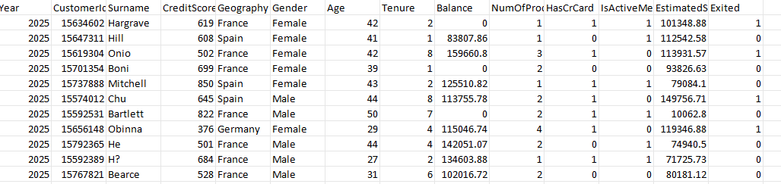

Data Pre-processing
The following pre-processing steps were performed:
- Verified dataset structure.
- Checked for missing values (none found).
- Removed non-predictive columns.
- Encoded categorical variables using One-Hot Encoding.
- Split the dataset into training (80%) and testing (20%).
- Applied StandardScaler where required.
- Prepared data for machine learning model development.

Exploratory Data Analysis (EDA)

Key Findings
- Approximately 20.37% of customers churned, while 79.63% remained with the bank.
- Germany recorded the highest churn rate among the three countries.
- Female customers exhibited a higher churn rate than male customers.
- Inactive customers were significantly more likely to leave.
- Customers with one banking product showed higher churn compared to those with two products.
- Older customers had a higher average churn rate.
- Customers who churned maintained higher average account balances than retained customers.
- Credit card ownership had minimal influence on customer churn.

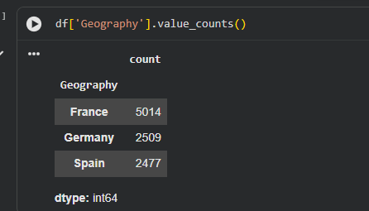
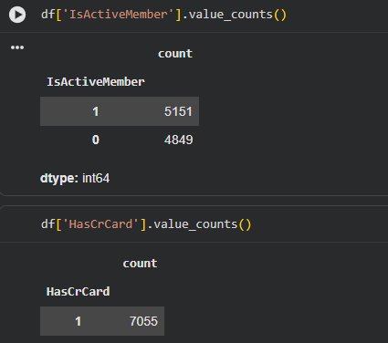

Machine Learning Model Development
Three classification algorithms were evaluated:
- Logistic Regression
- Decision Tree
- Random Forest
Each model was assessed using:
- Accuracy
- Precision
- Recall
- F1 Score
- ROC-AUC Score
After comparing all models, Random Forest achieved the best overall predictive performance and was selected as the final model.

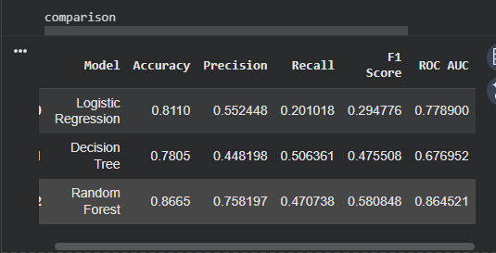

Risk Scoring
The Random Forest model generated churn probabilities for each customer.
Based on these probabilities, customers were classified into three categories:
Risk Score | Category
0.00 – 0.30 | Low Risk
0.31 – 0.70 | Medium Risk
0.71 – 1.00 | High Risk
This risk scoring system enables the bank to prioritize customers for retention campaigns and allocate resources efficiently.

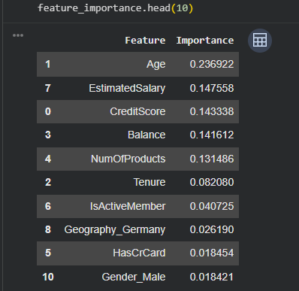

Dashboard Overview
An interactive Power BI dashboard was developed consisting of four pages:

Executive Dashboard
Provides KPIs including total customers, churn rate, average balance, and average credit score.

Customer Analysis
Analyses churn behaviour across age, geography, product usage, and customer activity.

Risk Dashboard
Displays customer risk categories and highlights high-risk customers using predictive model outputs.

Insights & Recommendations
Summarizes the key findings and provides strategic recommendations for reducing customer churn.

Key Insights
- Germany experienced the highest customer churn.
- Inactive customers showed significantly higher churn rates.
- Customers with a single banking product were more likely to leave.
- Older customers demonstrated greater churn tendencies.
- High account balance customers also showed elevated churn risk.
- Random Forest produced the strongest predictive performance among all evaluated models.

Business Recommendations
- Develop targeted retention campaigns for customers in Germany.
- Increase engagement initiatives for inactive customers.
- Encourage customers to adopt additional banking products.
- Monitor high-risk customers using predictive risk scores.
- Offer personalized services and loyalty incentives to customers identified as likely to churn.

Conclusion
This project successfully developed a machine learning-based customer churn prediction system using the Random Forest algorithm. By combining predictive modelling with customer risk scoring, the project enables banks to proactively identify customers who are likely to leave and implement effective retention strategies.
The Power BI dashboard transforms analytical findings into actionable business insights, allowing decision-makers to monitor churn trends, understand key drivers, and prioritize high-risk customers. Overall, the project demonstrates how data analytics and machine learning can support strategic decision-making, improve customer retention, and contribute to long-term business growth.

